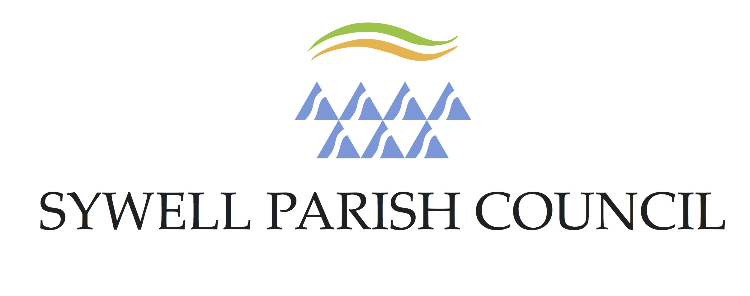

DATA PROTECTION POLICY

Introduction

Sywell Parish Council is fully committed to compliance with the requirements of the Data Protection Act 2018 (“the Act”), which came into force on the 25 May 2018.

The council will therefore follow procedures that aim to ensure that all employees, elected members, contractors, agents, consultants, partners or other servants of the council who have access to any personal data held by or on behalf of the council, are fully aware of and abide by their duties and responsibilities under the Act.

Statement of policy

In order to operate efficiently, Sywell Parish Council has to collect and use information about people with whom it works. These may include members of the public, current, past and prospective employees, clients and customers, and suppliers. In addition, it may be required by law to collect and use information in order to comply with the requirements of central government. This personal information must be handled and dealt with properly, however it is collected, recorded and used, and whether it be on paper, in computer records or recorded by any other means there are safeguards within the Act to ensure this.

Sywell Parish Council regards the lawful and correct treatment of personal information as very important to its successful operations and to maintaining confidence between the council and those with whom it carries out business. The council will ensure that it treats personal information lawfully and correctly.
To this end the council fully endorses and adheres to the Principles of Data Protection as set out in the Data Protection Act 1998.

The principles of data protection

The Act stipulates that anyone processing personal data must comply with Eight Principles of good
practice. These Principles are legally enforceable. The Principles require that personal information:

1. Shall be processed fairly and lawfully and in particular, shall not be processed unless specific conditions are met;
2. Shall be obtained only for one or more specified and lawful purposes and shall not be further processed in any manner incompatible with that purpose or those purposes;
3. Shall be adequate, relevant and not excessive in relation to the purpose or purposes for which it is processed;
4. Shall be accurate and where necessary, kept up to date;
5. Shall not be kept for longer than is necessary for that purpose or those purposes;
6. Shall be processed in accordance with the rights of data subjects under the Act;
7. Shall be kept secure i.e. protected by an appropriate degree of security;
8. Shall not be transferred to a country or territory outside the European Economic Area, unless that country or territory ensures an adequate level of data protection.

The Act provides conditions for the processing of any personal data. It also makes a distinction between personal data and “sensitive” personal data.

Personal data is defined as, data relating to a living individual who can be identified from:

• That data;
• That data and other information which is in the possession of, or is likely to come into the possession of the data controller and includes an expression of opinion about the individual and any indication of the intentions of the data controller, or any other person in respect of the individual.

Sensitive personal data is defined as personal data consisting of information as to:

• Racial or ethnic origin;
• Political opinion;
• Religious or other beliefs;
• Trade union membership;
• Physical or mental health or condition;
• Sexual life;
• Criminal proceedings or convictions.

Handling of personal/sensitive information

Sywell Parish Council will, through appropriate management and the use of criteria and controls:-

• Observe fully conditions regarding the fair collection and use of personal information;
• Meet its legal obligations to specify the purpose for which information is used;
• Collect and process appropriate information and only to the extent that it is needed to fulfil operational needs or to comply with any legal requirements;
• Ensure the quality of information used;
• Apply checks to determine the length of time information is held;
• Take appropriate measures to safeguard personal information;
• Ensure that the rights of people about whom the information is held can be fully exercised under the Act.

These include:

• The right to be informed that processing is being undertaken;
• The right of access to one’s personal information within the statutory 40 days;
• The right to correct, rectify, block or erase information regarded as wrong information.

Implementation

The Clerk of Sywell Parish Council is responsible for ensuring adherence with the Data Protection Act.

Notification to the Information Commissioner

The Information Commissioner maintains a public register of data controllers. Sywell Parish Council is registered as such.

The Data Protection Act 1998 requires every data controller who is processing personal data, to notify and renew their notification, on an annual basis. Failure to do so is a criminal offence.

The Information Officer will review the Data Protection Register annually, prior to notification to the Information Commissioner.

Any changes to the register must be notified to the Information Commissioner, within 28 days.
To this end, any changes made between reviews will be brought to the attention of the Information Officer immediately.

Appendix 1 – Website and Cookies

Sywell Parish Council will

1. Seek the *consent of each visitor to their website before a cookie is saved to the visitors computer.
2. Each cookie will be identified in the Privacy Policy and its purpose explained
3. Visitors, having previously accepted cookies, will be able to withdraw that consent at any time.

*It should be noted that cookies that are essential in order to make a site work are exempt from consent but not from being detailed in the Privacy Policy.

Last Reviewed: May 2025
Review Due: May 2026

